MBA Course: Financial Innovation and ESG

"본 강의는 사회적가치연구원(www.cses.re.kr)의 2022년 사회적가치 강의 지원사업에 선정되어 소정의 강의개발비를 지원받은 과목입니다."

Week 02

Week 02

Student presentation schedule
ESG at WeChat Pay to Support SMEs
이수만 손 들어줬다?…법원은 'SM 주주' 손을 들어줬다

Requirement
* One case study: ESG and financial innovation.
핀테크 기업 등 financial innovation을 추구하고 있는 기업의 ESG관련 이슈 및 기존 금융에서 유사사례 비교 (사례연구).
* The final reports would include the updated mid-term reports. If students do not like their mid-term report, they can write totally different reports.
* Submit to cwp112477@hanyang.ac.kr (filename: 성함+과목명+논문제목.docx)

Term paper format
Term paper format youtube (Please watch)
* Midterm report: 2023/4/25 23:59
* Final report: 2023/6/12 23:59

위 필수 아이디어를 깊게 연구하여 하나의 보고서를 써도 되고 필수 아이디어와 함께 별도의 리포트를 하나 더 개발해도 됨. Find relevant information in the links below.
http://scholar.google.com
http://www.dbpia.com
http://library.hanyang.ac.kr

Papers
Hafiz, K. (2008). Case study example. The qualitative report, 13(4), 544-559.
Gerring, J. (2004). What is a case study and what is it good for?. American political science review, 98(2), 341-354.
ESG and Ukraine
EU, '작업증명 가상자산 제한' 다시 담은 미카 표결 부친다
https://en.wikipedia.org/wiki/Byzantine_fault

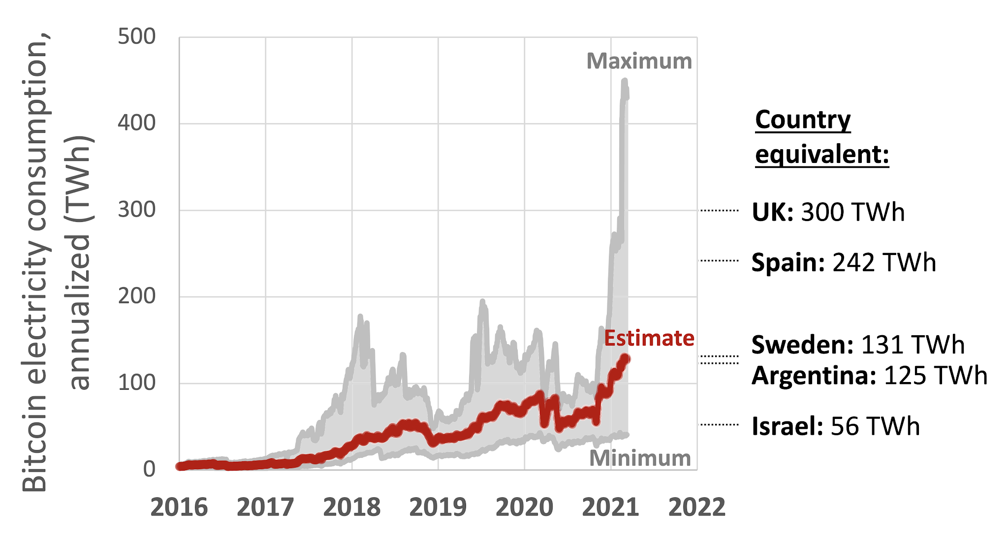

Creating crypto

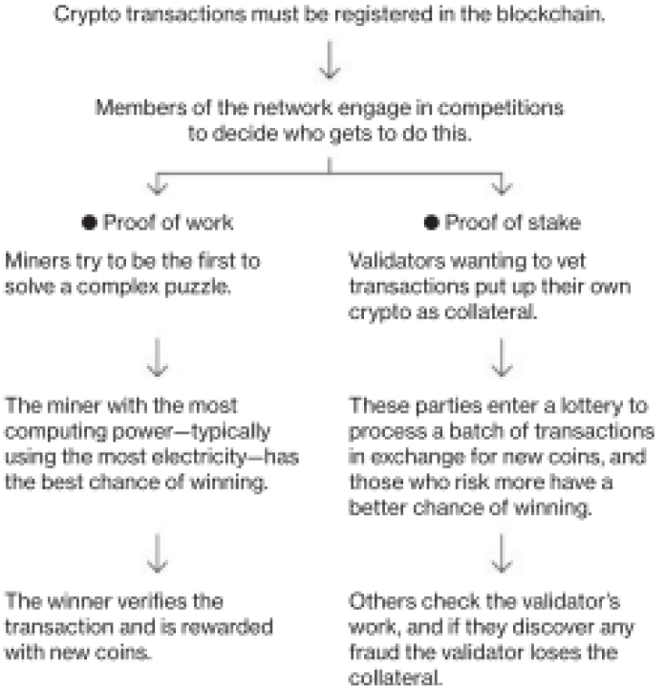

* Etherium: migrating from PoW to PoS will reduce its energy use by 99.95%,
* Solana: proof of stake + proof of history. transactions are given timestamps to speed up processing.
* Algorand: give all online users a chance to be randomly and secretly selected to propose and vote on batches of transactions that need confirming, which each party’s influence tied to how many tokens she owns.
* Tron: let users elect delegates, called super representatives, to validate transactions in six hour shifts and to receive new coins for their work.
* Filecoin: parties to compete to provide bandwidth or digital storage to the network in exchange for new coins.

Problems

* PoS codes are so complex that there’s a greater risk of undetected software bugs
* More susceptible to censorship (once an entity or group acquires more than 50% the tokens) vs PoW (a small number of miners typically control most of the network → manipulation)

Proof of History is a sequence of computation that can provide a way to cryptographically verify passage of time between two events.

