MBA Course: Financial Innovation and ESG

"본 강의는 사회적가치연구원(www.cses.re.kr)의 2022년 사회적가치 강의 지원사업에 선정되어 소정의 강의개발비를 지원받은 과목입니다."

Week 05 20230401 (Guest lecture by Vivien Choi at Citigroup)

Week 05
Guest lecture by Vivien Choi at Citigroup
Securitizing a Cure for Cancer (cfainstitute.org), Can Financial Engineering Cure Cancer? | Andrew Lo | TEDxCambridge

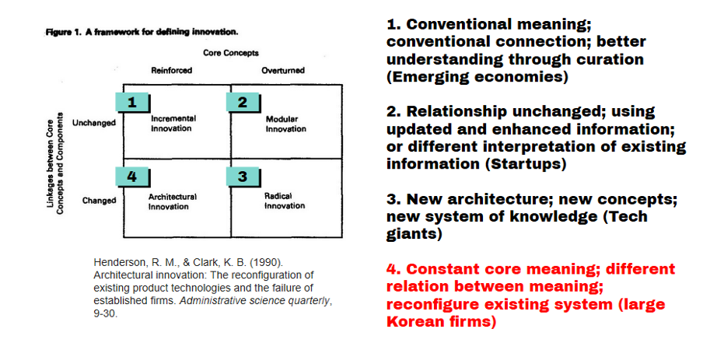

# Lecture Notes: Applying Architectural Innovation to Finance ESG Projects

## 1. **Introduction**
- **Architectural Innovation**: Refers to the reconfiguration of existing technologies or systems to create new products, services, or methods. Unlike radical innovation, which introduces completely new ideas, architectural innovation modifies the way in which components interact, leading to new frameworks or approaches within existing structures.

- **ESG Projects**: ESG (Environmental, Social, and Governance) projects focus on improving sustainability, social responsibility, and governance standards in business operations. Financing these projects often requires innovative approaches due to their long-term, multi-dimensional impact on society and the environment.

### Objective:
This lecture focuses on how architectural innovation can be applied to finance ESG projects, enabling more efficient capital allocation, improved investor engagement, and greater impact in achieving sustainability goals.

---

## 2. **Key Concepts**
### 2.1 **Architectural Innovation in Finance**
- **Reconfiguration of Financial Systems**: Architectural innovation in finance involves altering the structure and interaction of financial instruments, institutions, and markets to support new business models, project funding, and investment strategies.

- **Existing Components in New Ways**: Rather than creating entirely new financial products, architectural innovation leverages existing instruments like bonds, loans, and equity but reconfigures their structure or purpose to better serve ESG objectives.

### 2.2 **ESG Project Financing**
- **Sustainable Financing**: Focuses on raising capital for projects that generate environmental, social, and governance benefits alongside financial returns.
- **Challenges in Financing**: ESG projects often face unique challenges such as longer payback periods, higher upfront costs, and complex risk profiles, requiring innovative financial approaches.

---

## 3. **Architectural Innovation Approaches to Finance ESG Projects**
### 3.1 **Green Bonds and Sustainability-Linked Bonds**
- **Reconfiguration**: Traditional bonds are restructured to become **Green Bonds**, where proceeds are allocated specifically to environmentally friendly projects, or **Sustainability-Linked Bonds**, where the bond’s interest rate is linked to the issuer’s achievement of ESG goals.

- **Impact**: By reconfiguring existing debt structures, architectural innovation allows the creation of financial products that directly support ESG goals while appealing to a broader range of investors who are committed to sustainability.

- **Example**: The European Investment Bank’s issuance of green bonds has financed renewable energy projects, showcasing how traditional fixed-income products can be adapted to meet environmental objectives.

### 3.2 **Blended Finance Models**
- **Reconfiguration**: Blended finance combines public, private, and philanthropic capital to reduce risks and attract private sector investment in ESG projects. This architectural innovation enables the reconfiguration of risk and return profiles by using public or concessional funds to de-risk investments.

- **Impact**: By blending funds, investors can support higher-risk projects that would otherwise struggle to secure financing, such as early-stage renewable energy projects or social infrastructure initiatives in developing countries.

- **Example**: The Global Environment Facility (GEF) uses blended finance to mobilize private sector investments in biodiversity and climate change mitigation projects by offering risk-sharing mechanisms.

### 3.3 **Sustainable Loan Structures**
- **Reconfiguration**: Traditional loan structures are modified to become **ESG-linked loans**, where loan terms such as interest rates or loan maturity are adjusted based on the borrower’s performance against pre-defined ESG criteria.

- **Impact**: This encourages borrowers to meet sustainability targets by offering financial incentives for improved ESG performance, such as lower interest rates for achieving emission reduction goals.

- **Example**: A manufacturing company may receive a lower interest rate on its loan if it reduces its carbon footprint by a certain percentage, incentivizing sustainability within its operations.

### 3.4 **Crowdfunding and Community-Based Financing**
- **Reconfiguration**: Crowdfunding platforms reconfigure traditional investment structures by allowing smaller investors to pool funds and finance ESG projects, often in local communities. This breaks down the conventional barriers to entry for project finance, enabling broader participation.

- **Impact**: Architectural innovation here democratizes access to capital for ESG projects, particularly for smaller-scale initiatives such as local renewable energy installations or community-led social projects.

- **Example**: Platforms like Trine and GoFundMe enable small-scale investments in solar energy projects in developing countries or social entrepreneurship ventures in underserved communities.

### 3.5 **Tokenization and Blockchain in ESG Finance**
- **Reconfiguration**: Blockchain technology and digital tokens allow for the reconfiguration of asset ownership and transparency in ESG finance. By tokenizing assets like green bonds or carbon credits, investors can buy fractional ownership and track the performance of ESG projects with enhanced transparency.

- **Impact**: Tokenization opens new pathways for funding ESG projects by creating more liquid markets and reducing the barriers for smaller investors to participate. Blockchain also ensures greater transparency in ESG reporting, making it easier to verify the impact of investments.

- **Example**: SolarCoin and other blockchain-based platforms provide digital incentives for solar energy generation, creating a new form of ESG financing through decentralized digital assets.

---

## 4. **Benefits of Applying Architectural Innovation to ESG Financing**
### 4.1 **Increased Capital Flows to ESG Projects**
- **Attraction of New Investors**: Architectural innovation in financial instruments broadens the appeal of ESG investments to traditional investors by adjusting risk profiles, offering competitive returns, and ensuring transparency in the use of funds.

- **Mobilizing Private Sector Investments**: Reconfiguring financial structures through mechanisms like blended finance or sustainability-linked loans can attract private sector capital that might otherwise avoid ESG projects due to perceived risks or lower returns.

### 4.2 **Alignment of Financial and Sustainability Goals**
- **Financial Incentives for Sustainability**: Linking financial terms to ESG performance ensures that companies have a direct financial incentive to improve their sustainability practices, leading to long-term benefits for both the environment and the business.

- **Scaling Impact**: Architectural innovation helps scale the impact of ESG projects by enabling access to larger pools of capital and enhancing the efficiency of funding mechanisms.

### 4.3 **Risk Mitigation**
- **Reducing Financial Risks**: By blending different types of capital or linking loan terms to performance, architectural innovation can reduce the financial risks associated with ESG projects, making them more attractive to investors.

- **Increased Transparency**: Using blockchain and other technologies improves transparency and accountability in ESG finance, reducing the risk of greenwashing and ensuring that funds are allocated effectively.

---

## 5. **Challenges and Considerations**
### 5.1 **Complexity of Implementation**
- **Coordination Required**: Reconfiguring financial structures to support ESG projects often involves complex coordination among multiple stakeholders, including public agencies, private investors, and project developers.

### 5.2 **Measurement and Standardization**
- **ESG Metric Challenges**: Measuring the success of ESG-linked financial instruments requires clear, standardized metrics for evaluating environmental, social, and governance outcomes. Lack of standardization can make it difficult to assess impact or compare results across projects.

### 5.3 **Regulatory and Compliance Issues**
- **Evolving Regulations**: ESG financing is subject to evolving regulatory frameworks that differ by jurisdiction. Investors and issuers must remain compliant with local laws and international standards, adding complexity to ESG-linked financial products.

---

## 6. **Conclusion**
Architectural innovation plays a critical role in enabling new ways to finance ESG projects by reconfiguring traditional financial instruments, creating innovative structures that appeal to a broader range of investors, and scaling sustainable development. Through the application of these innovative models, finance can be a powerful tool in achieving environmental, social, and governance goals. However, successful implementation requires careful consideration of regulatory environments, measurement challenges, and coordination among stakeholders.

By applying architectural innovation, we can reimagine the future of sustainable finance and unlock the capital necessary to meet global sustainability targets.

---

### **Discussion Questions:**
1. What are the key barriers to financing ESG projects using traditional financial instruments?
2. How does architectural innovation improve the alignment between financial performance and sustainability objectives?
3. What role can blockchain technology play in enhancing transparency and accountability in ESG finance?

---

